Powers of Ten Card Packets

The card packets for the sorting activity are on the next two pages. They should be printed on card stock (either in color or black and white), cut up, and put into envelopes or paper clipped together—one packet per group of four students.

Each row of the packet shows a system at the four different scales:
- Plant system: 1) forest, 2) tree, 3) stomata on leaf, 4) glucose molecule
- People system: 1) city of people, 2) person, 3) red blood cell, 4) oxygen molecule
- Water system: 1) Large lake, 2) raindrop, 3) snowflake, 4) water molecule
- Fuel system: 1) natural gas deposit, 2) propane bottle, 3) close-up flame 4) propane molecule
- Fire system: 1) forest fire, 2) tree on fire, 3) soot, 4) carbon atom
- Pollen System: 1) atmosphere, 2) cloud of pollen, 3) pollen, 4) cellulose (in cell wall)

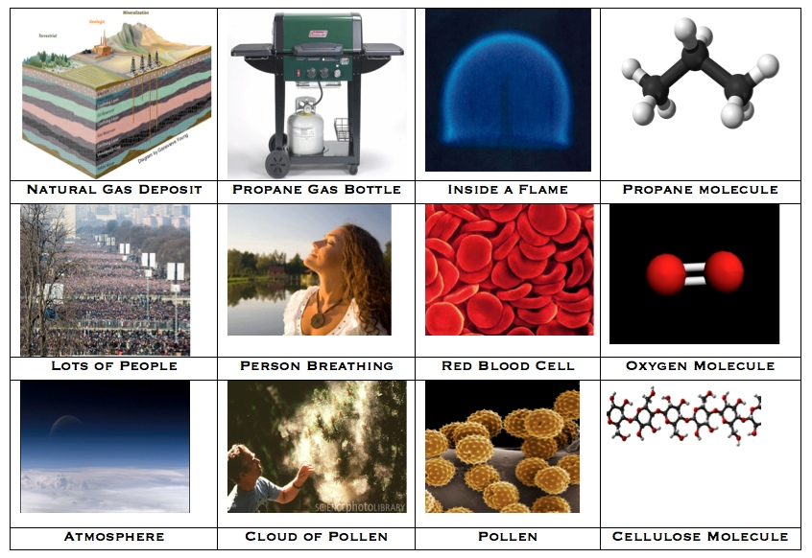
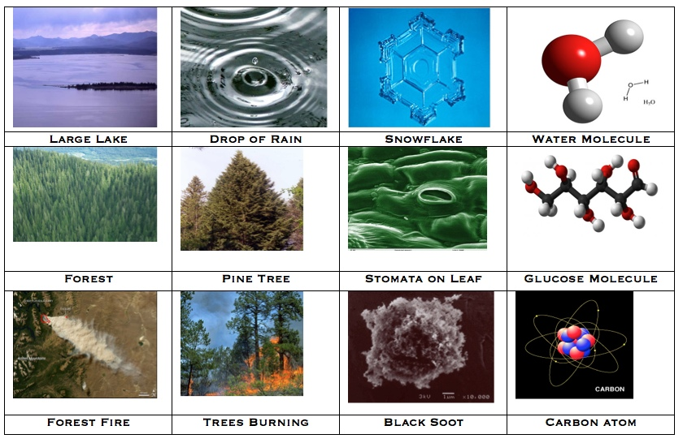

Materials Cards: Organic and Inorganic Materials
Lesson 5, Activity 2
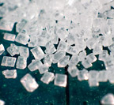  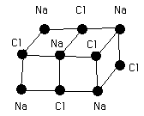 | 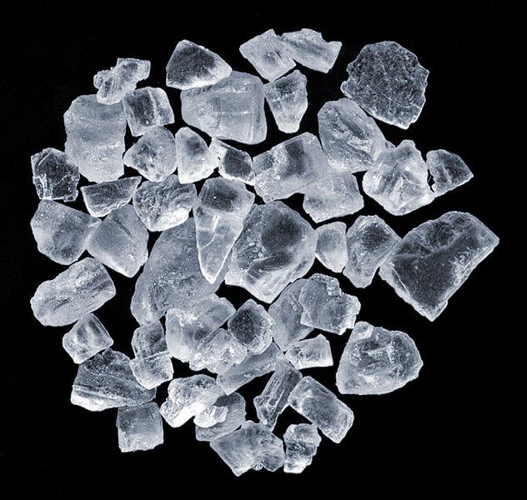  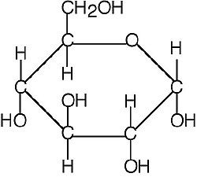
Table Salt (NaCl) | Sugar/Glucose (C₆H₁₂O₆)
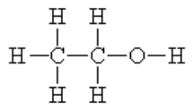  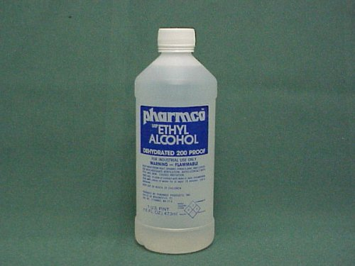 | 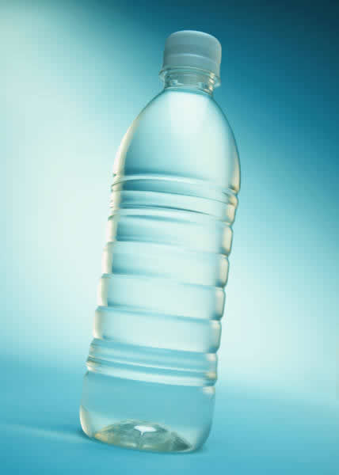  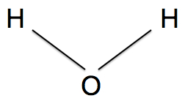
Ethyl Alcohol or Ethanol (C₂H₅OH) | Water (H₂O)

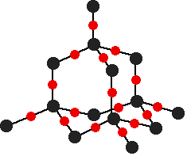  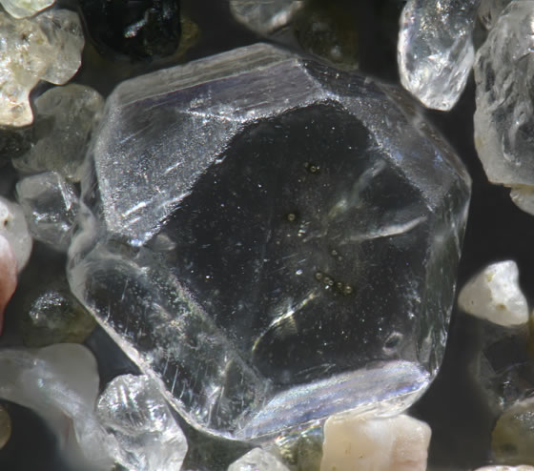  Silicon  Oxygen | 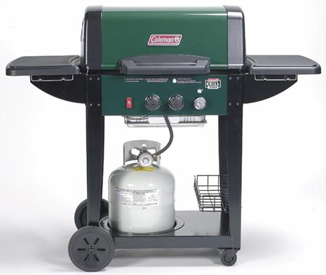  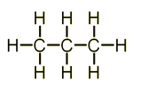
Sand/Quartz (SiO₂) | Propane Gas (C₃H₈)
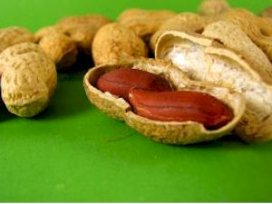  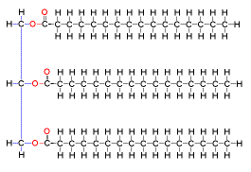 | 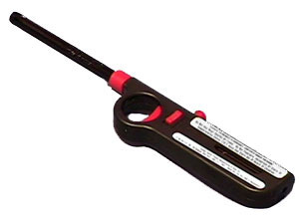  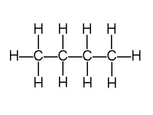
Lipids/Fats | Butane (C₄H₁₀)

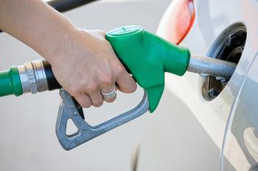  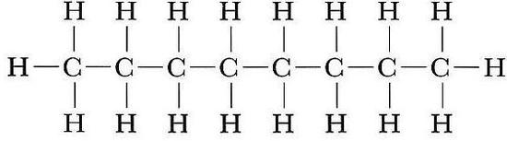 |   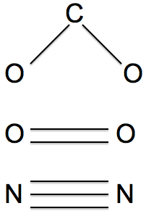
Gasoline/Octane (C₈H₁₈) | Air (N₂, O₂, CO₂)
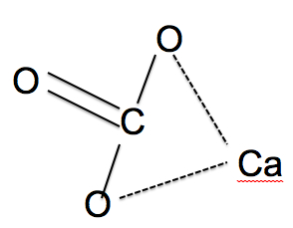  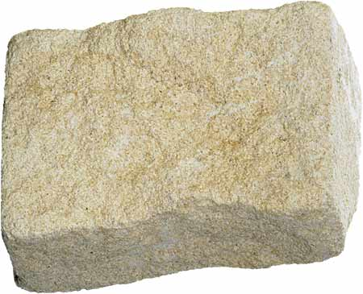 | 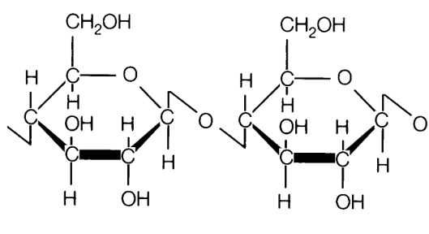  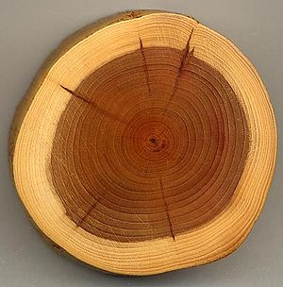
Limestone/Calcium Carbonate (CaCO₃) | Cellulose (C₅H₁₀)_{n}

